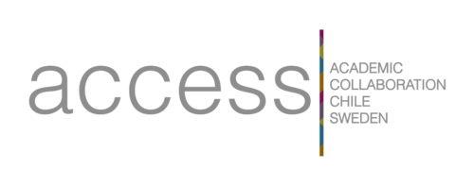
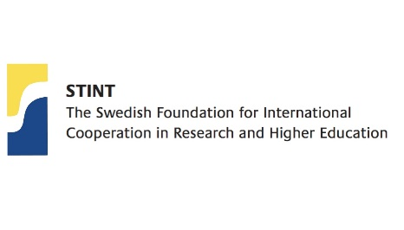

Confirmation of Employment for Application to Create Joint Courses through ACCESS and Receive Funding for Course Conveners

This letter is to verify that the below undersigned confirm that the applicant is employed by an ACCESS member university and not merely affiliated with this university.
ACCESS member universities include: Lund University, Pontificia Universidad Catolica de Chile, Royal Institute of Technology, Södertörn University, Universidad de Chile, Universidad de Concepcion, University of Gothenburg, Universidad de Magallanes, Universidad de O´Higgins, Uppsala University, University of Santiago, University of Aysén, Universidad de La Frontera, Universidad Técnica Federico Santa María, Swedish University of Agricultural Sciences and Stockholm University
Please note: Due to previous results and with the aim to have a balance regarding funding this call will give priority to applicants from University of Gothenburg, Uppsala University, Lund University, Södertörn University and KTH Royal Institute for Technology. However, we still encourage participants from all ACCESS-universities to apply.
Name of Applicant: _______________________________________________
Department of Applicant: ___________________________________________
University of Applicant: _____________________________________________

The undersigned Head of Department also confirms that the undersigned applicant will be allowed to dedicate ____________ number of hours to the planning and teaching of the Joint Course they are applying to teach. These hours will be allocated within the following timeframe: _____________________________________________________________.

___________________________________________________
Date and signature of applicant

___________________________________________________
Date and signature of Head of Department or equivalent

