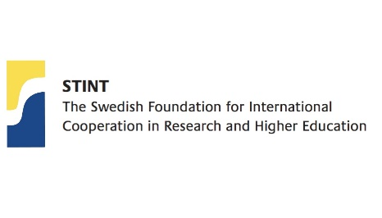

ACCESS PhD Course Plan
- General Information

Course title:
Course co-conveners:
Chile:

Sweden:

Course credits (ECTS):

Course length (full time weeks):

Course period:
Language of Instruction:  (note: this must be English) | English
Level: | Open to PhD and Post docs of ACCESS universities.
Entry requirements:

Course online and teaching management platform:
(Zoom and Canvas are recommended.)

Suggested deadline for course registration:

Course abstract

(max 200 words).
This information will be published on the ACCESS website if your course is selected. Therefore, you should also include information about the course layout and structure.

- Course description
Course Aims
Learning Outcomes:
On completion of the course, participants shall be able to:

Course content:

Course format and pedagogy:

Assessment:

Grading Scale (only pass and fail allowed at Swedish universities):

- Budget
Each project selected will be eligible to receive up to 6,000 USD from each of the participating Chilean and Swedish universities (min 1, max 2 universities per country). The Universities will fund their respective costs for salaries (up to 6,000 USD). Please check with the ACCESS Coordinator at your university to determine if this funding is allocated in-kind or funded separately.
STINT matches the amount of funding corresponding to the number of Swedish universities participating in the project (minimum 1, maximum 2).
- One Swedish university will receive up to 6,000 USD from STINT.
- Two Swedish universities will receive up to 12,000 USD from STINT.
The funding from STINT is to be used only for:
- Travel and accommodation from both countries for the course conveners (e.g. either for a kickoff meeting, physical course meeting, or other planning meeting between course conveners).
- Organisational costs for a physical course activity (e.g. venue, food or relevant excursions for physical meeting in Chile or Sweden)
The funding cannot be used to provide travel for in-person courses for the students. The funding will only cover travel for the course conveners.
Please use the section below to elaborate on your proposed budget.
Course Budget, SEK | Funding from Swedish University | Funding From Chilean University | STINT Funding
Salary for Co-Conveners |  |  | N/A
Salary for additional teachers (not Co-conveners) |  |  | N/A
Travel costs for Co-Conveners
Accommodation costs for Co-Conveners
Venue costs for physical course activity
Food costs for physical course activity
Excursion costs for physical course activity
Miscellaneous other costs (please describe)
Total Cost

- Distribution of Responsibilities
Distribution of responsibilities:
Please describe the plan for distribution of responsibilities among the course conveners

